Git Status
Using command- git remote -v, we verified the origin is present with the Central repository.
- Git status- to verify the current status if files worked on my local path- Desktop
- Git Pull- I pulled to check if anything is present in central repository that was directly worked in GitHub.
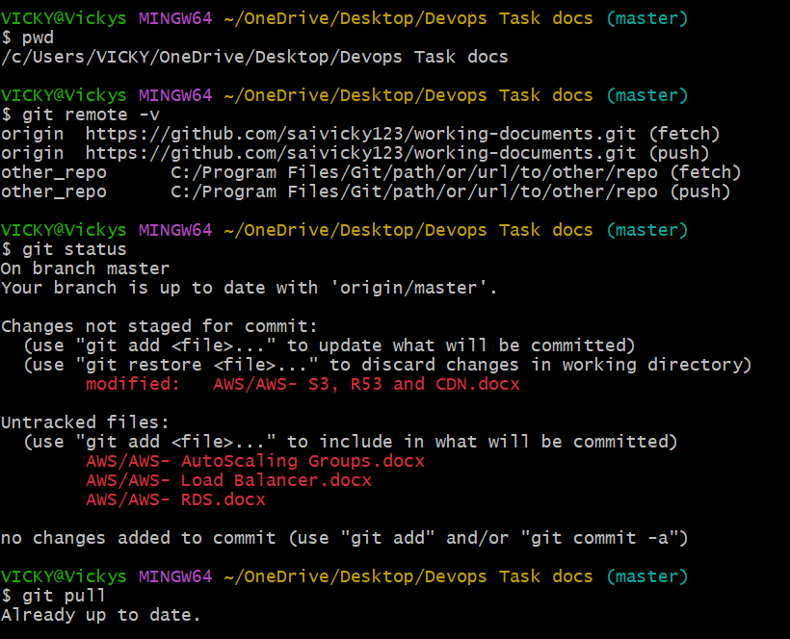

- Git add . – I have added 2 more documents to the local path and need to push.
- Git commit -m “message” – Uploaded as of 22-12-2025
- Git push -u origin master- No, we pushed all the documents to GitHub.
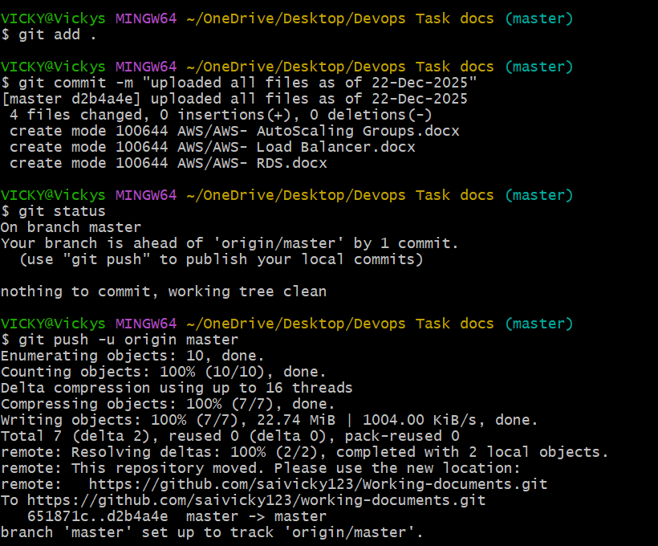

- Git log –oneline- I verified all the commits and the recent commit added as well.
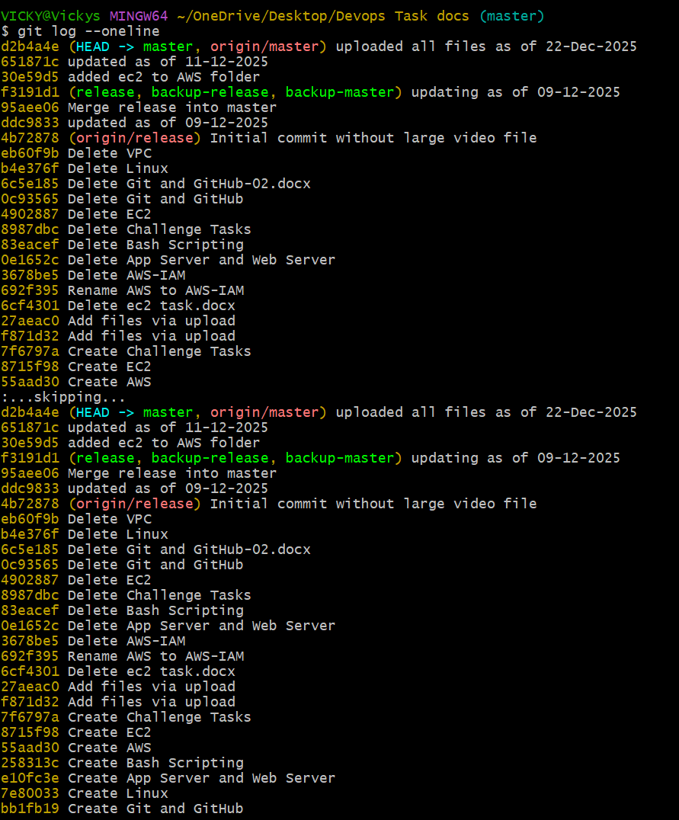
- Finally verified in GitHub, all documents are uploaded.
